Market Monitor - South Sudan - 2026-01

Highlights
South Sudan's market outlook for January 2026 remains overwhelmingly negative, characterized by escalating food prices and a widening severe food insecurity crisis. Projections indicate a significant expansion of IPC Phase 4 conditions across 35 counties by May 2026.
The national food basket cost increased to SSP 9,256.04, marking a ↑2.6% month-on-month (MoM) increase and a substantial ↑19.4% year-on-year (YoY) surge. Among key commodities, Wheat flour prices experienced significant upward pressure, increasing by ↑2.6% MoM and a substantial ↑19.4% YoY, directly impacting household purchasing power and contributing to severe food insecurity.
Key Market Drivers:
- Escalating conflict and localized violence
- Protracted impacts of flooding and climate shocks
- High food prices and deteriorating economic stability
- High refugee and returnee presence
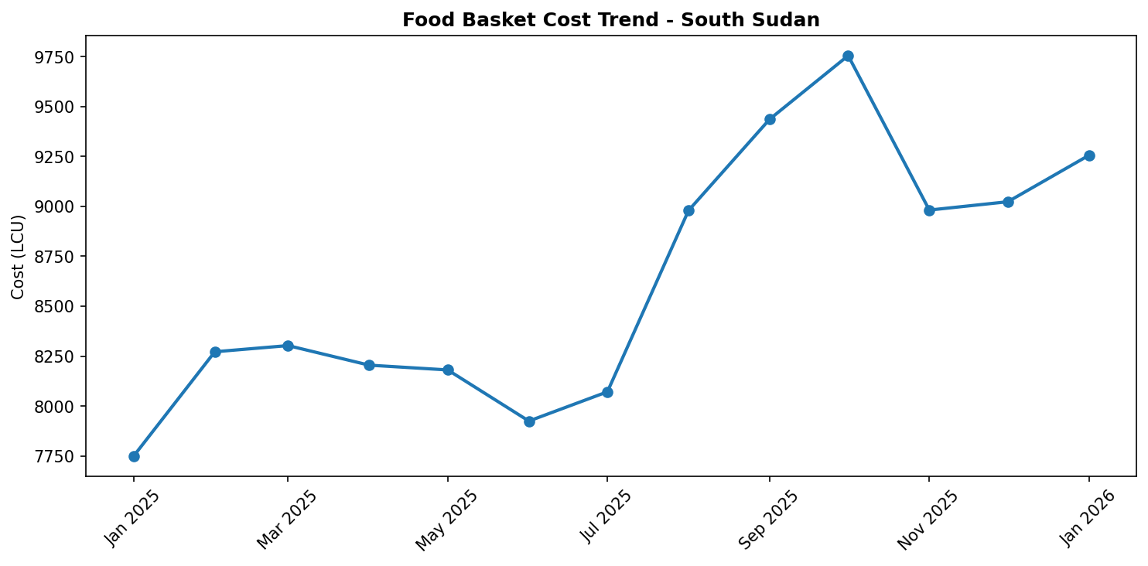
Food basket cost trend

Market Overview
January 2026 saw South Sudan's market conditions deteriorate further, characterized by a persistent upward trajectory in food prices across the country. This concerning trend is primarily driven by a confluence of severe market drivers, including escalating conflict and widespread localized violence, the protracted impacts of recurrent flooding and other climate shocks, pervasive high food prices amidst a deteriorating economic environment, and the substantial presence of refugees and returnees. These factors collectively perpetuate severe humanitarian and food security outcomes. The national outlook remains overwhelmingly negative, with projections indicating a significant expansion of severe food insecurity (IPC Phase 4) to 35 counties by May 2026. While South Sudan launched its Roadmap on Anticipatory Action 2025-2030 (SSRAA) in early January to foster proactive risk management, the immediate challenges posed by ongoing crises, including increasingly frequent and severe climate-related and human-induced shocks, are expected to continue driving market instability and worsening food security outcomes. The cumulative effects of these multifaceted crises underscore a fragile market environment where basic necessities are becoming increasingly unaffordable for a vulnerable population.

Commodity Analysis
Analysis of staple commodities in January 2026 reveals significant inflationary pressures, with wheat flour serving as a key indicator of the broader economic distress. Wheat flour prices experienced a notable 2.6% month-over-month increase, contributing to a substantial 19.4% year-over-year rise. This persistent upward trajectory for a fundamental food item directly exacerbates severe food insecurity across South Sudan, diminishing the purchasing power of households and making basic foodstuffs increasingly inaccessible. The continuous escalation in wheat flour prices mirrors the overarching trend of high food prices and a deteriorating economic stability that afflicts the nation. These price surges are compounded by disruptions to supply chains caused by insecurity and climate shocks, further constraining market functionality and the availability of essential goods. The high cost of vital commodities, like wheat flour, is a critical component perpetuating the severe humanitarian crisis, highlighting the urgent need for interventions that address both immediate food access and underlying economic vulnerabilities.
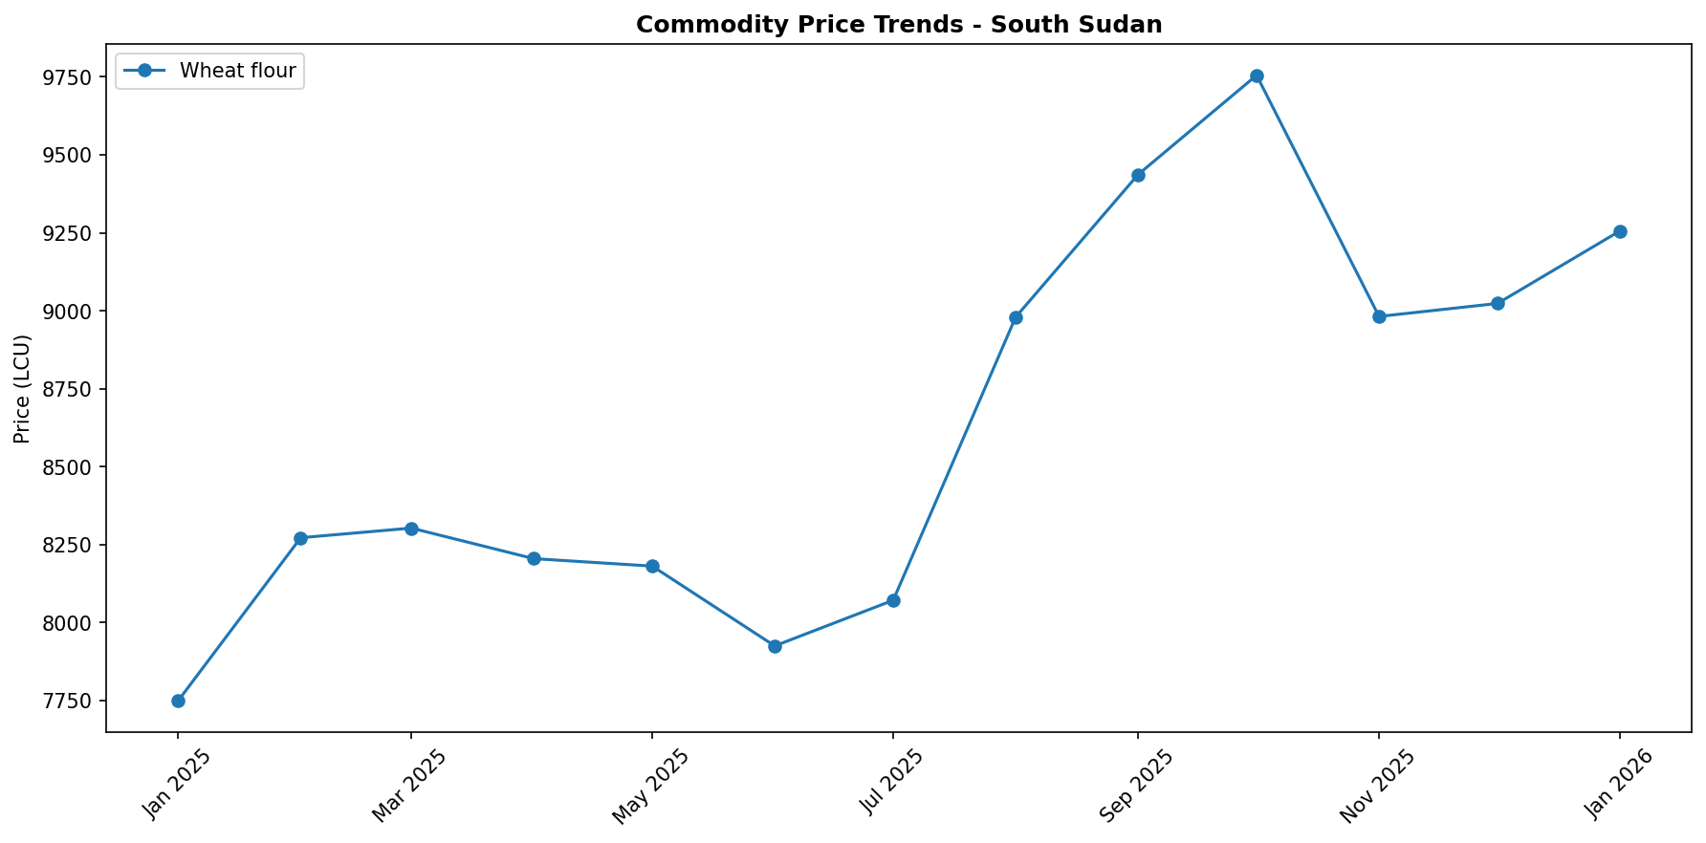

Regional Highlights
Nationally, South Sudan is bracing for a deepening food security crisis, with severe food insecurity (IPC Phase 4) anticipated to spread to 35 counties by May 2026. This reflects the pervasive impact of high food prices, economic instability, and the cumulative effects of conflict, climate shocks, and displacement. Against this backdrop, Jonglei State, particularly Lankien town in Nyirol County, stands out due to an acute and localized security crisis. The region experienced airstrikes near Lankien town in late December, immediately followed by a rapid deterioration in security, compelling Médecins Sans Frontières (MSF) to evacuate key staff from its healthcare facility by the end of 2025. Such intense localized conflict inevitably severely disrupts market functionality, cripples supply chains, and severely restricts access to food and essential services for the affected population. This exacerbates humanitarian conditions in Jonglei State beyond the already severe national average, leaving communities increasingly vulnerable and isolated from crucial aid and market access.
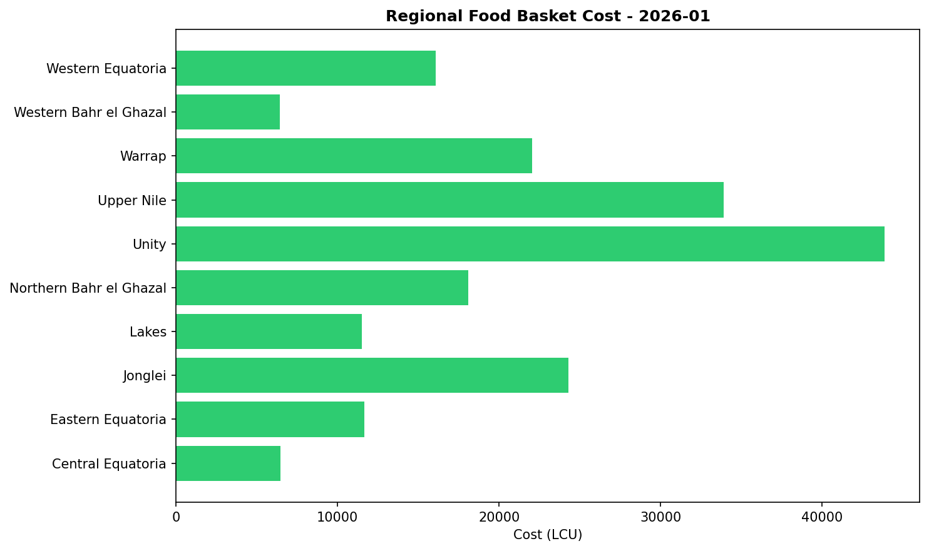

References
- [rw_4193581] ReliefWeb (2026-01-08) South Sudan: Food Security Outlook Update: Conflict disrupts humanitarian access, sustaining Emergency and risk of Famine in Nasir, December 2025
https://reliefweb.int/node/4193581
- [rw_4193350] ReliefWeb (2026-01-06) The South Sudan Roadmap on Anticipatory Action 2025 -2030
https://reliefweb.int/node/4193350
- [rw_4193308] ReliefWeb (2026-01-06) South Sudan Joint Market Monitoring Initiative (JMMI) 1 - 7 December 2025
https://reliefweb.int/node/4193308
- [rw_4193074] ReliefWeb (2025-12-31) South Sudan: MSF Evacuates Staff from Lankien Healthcare Facility Following Airstrikes
https://reliefweb.int/node/4193074
- [rw_4193033] ReliefWeb (2025-12-31) WFP South Sudan Country Brief, November 2025
https://reliefweb.int/node/4193033
- [rw_4192953] ReliefWeb (2025-12-30) South Sudan: Humanitarian Snapshot (November 2025)
https://reliefweb.int/node/4192953
- [rw_4192739] ReliefWeb (2025-12-26) South Sudan Health Cluster Strategy 2026
https://reliefweb.int/node/4192739
- [rw_4192527] ReliefWeb (2025-12-23) Norway supports WFP in addressing food needs in South Sudan as levels of food insecurity surge
https://reliefweb.int/node/4192527
- [rw_4192486] ReliefWeb (2025-12-23) Norway supports WFP in addressing food needs in South Sudan as levels of food insecurity surge
https://reliefweb.int/node/4192486
- [rw_4191892] ReliefWeb (2025-12-18) Sudan Situation: UNHCR Monthly External Update #112 - October 2025
https://reliefweb.int/node/4191892

